RESUME 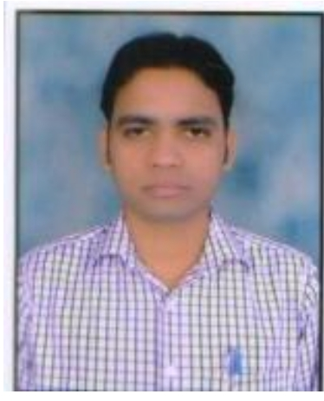

Akshay kumar Patel
Permanent Adress:-
Village Sadashivpura, Dewas. (M.P.). Pin-455001
Local Address: -
40, Mansarovar Society Village –Charta T.A. –kalol
Dist. Gandhinagar
Mob. 9722784136
E-mail:Akshaypatel1606@gmail.com
Professional Objective:

To obtain a challenging position in an organization where I can contribute my knowledge and skills and to be a part of team where I learn and deliver my best and grow with the organization.

Interpersonal Skills:
- Ability to deal with people and a natural team worker.
- Willingness to learn new things.
- Positive attitude.
- Hard working.
- Risk Taker.
- Self Starter.

Key Skills: Thorough knowledge of ICH-GMP guidelines, GMP.

Equipment Knowledge:
- Mixing and Filtration vessels
- Linear and Rotatory glass bottle/Vials washing M/C (Ambica & Klenzaids).
- HPHV Autoclave cum Bung processor (metal chem. lab)
- Filling Machines: -
Four Head Plumat filling & Sealing machine BFL 354
Glass Filling M/C (Liquipack)
Bausch & Strobel Vial Filling Machine
Ravindra Engineering Filling Machine

- Glass Bottle sealing m/c (karc)
- Depyrogenastion Tunnel (Klenzaid)
- Moist Heat Sterilizer (Metal chem. lab. And Ravindra Engineering)
- Sticker Labeling M/C (Maharishi)
- PVC Wrapping M/C (Maharishi and Euflux)
- Depth Filter Press (Pharma Lab)
- Automated CIP/SIP System Pharmalab
- DHS (ICOS)
- Garment Washing Machine (Auragarmax)
- Filter Integrity Tester (Millipore and Palltronic)
- Load Cell Mettler toledo
- Online Particle counter ISO Air
- Differential Pressure Monitoring System
- Refrigrator and Deep Freeze Monitoring System

DESIGNATION:- Production Executive
Total Experience: 14.00 years in inject able

AREAS OF INTERSEST:
- Production
Academic profile:

Degree/Examination | Institute/Uni./Board | Year of passing | Percentage
SSC(X) | M.P.Board Dewas. | 2004 | 65%
HSC (XII) | M.P.Board Dewas | 2006 | 70%
B.Pharmacy | PCST-Pharmacy, Bhopal | 2010 | 69%

PROJECTS UNDERTAKEN:
MAJOR PROJECT:

Title: “Occupational disease Psoriasis”

WORKING EXPERIENCE:-

- Pentagon lab ltd. Dewas (M.P.) 01.03year experience in injectable Production from June-2010 to sep-2011.

- Denis Chem Lab ltd. Gandhinagar (Gujarat) approx. 11 years’ Experience from Sep- 2011 to June-2022 as a Production Executive.

- Torrent Pharma Indrad Location from June-2022 to July -2024
as a Production Executive.
- Currently Working in Lupin Pharma as a Production Executive in Pithampur (Indore) Location from July -2024 to till date.

JOB PROFILE:
General Purpose
To plan, organize and control production in an organization to ensure that goods are produced efficiently, on time, within budget and to standard. Planning, coordination and control of manufacturing processes.
To involve in the pre-production (planning) stage as well as the production (control and supervision) stage. Dealing with people, particularly those who work in team.

Job Responsibility
- Implement and control the production schedule.
- Review and adjust the schedule in case of emergency production requirement.
- Proper manage human and material to meet production targets.
- Coordinate with Production Manager, CEO and Engineer Head about equipment maintenance and functional requirement.
- Taking active participation in Media fill activity, and validation of different equipment of production area.
- Ensure that standard operating procedures are adhered to.
- Analyze production inferiority to detect and correct problems.
- Determine and implement improvements to the production process.
- Prepare and maintain production reports & Documents.
- Implement cost control programs.
- Ensure efficient collaboration and co-ordination between relevant departments like Store, Dispatch, QC, QA and management.
- Making sure that products are produced on time and are of good quality.
- Supervising and motivating a team of workers.
- Identifying training needs of junior production staff, operators & workers.
- To check the maintenance of the department and equipment.
- To ensure that the appropriate process validations and calibrations of control equipment are performed and recorded.
- Assist in defining manufacturing processes for the product to be manufactured in house.
- Make provisions for safe and easy handling of the product at all stages of manufacturing.
- Prepare Annual, Monthly and weekly Production Plans.
- Provide means of identification to products at all stages of production and packing.
- Monitor and control product quality at all in-process stages.
- Support QA to conduct Internal Quality Audits and improve quality system in terms effectiveness and continuing suitability.
HOBBIES & INTEREST:
- Playing Cricket.
- Listening Music.

Personal Profile:
Name : Akshay kumar Patel
Date of Birth : 15-Dec-1987.
Father’s Name : Mr.B.L. Patel
Permanent Add. : 52, yashwant colony moti bunglow Dewas (M.P.).
Phone No. : +09722784136
Marital status : married
Language Known : Hindi, English
Nationality : Indian.
Declaration:
I hereby declare that the information furnished above is true to the best of my knowledge.
PLACE :
DATE: (Akshay kumar Patel)

