Hemanth Joshi
TEL: (086) 15802247861
hemantjoshee@rediffmail.com

PROFILE-Career summary

A highly motivated, hardworking and team worker in the pharmaceutical research field having professional experience of 19yrs, in Formulation and technology development in pertaining to formulation research, with a focus on products with technical complexity addressing unmet customer needs that would advance healthcare and open up a large area of product portfolio. Skilled in handling multiple projects ensuring scalable product development strategy .

Handled ANDAs - Successful development and launch of simple and complex ANDAs of Para III， Para IV category with timelines target of First-to-file or First-to-launch.

A process of innovation that yields into a predictable breakthrough outcome. Experienced in Formulation development, with easily scalable manufacturing process. data-centric, navigate through computational platforms with QbD and DoE principles to guide formulation and manufacturing process development.

Culminating the fundamental scientific knowledge/experience in formulation development and manufacturing process enabling scalability and ease of operation at large scale, supported by data-driven conclusions and mechanistic modeling.

Data mining from public domain or market intelligence in biopharmaceutics to novel problems such as Gastroplus, Phoenix packages, thus linking product development with critical biopharmaceutical and pharmacokinetic properties of drug product for ensuring bio success in order to accelerate drug product development Experienced in the field of bio studies, accelerate drug product development.

Concluding with creative idea with, domain experience and knowledge for addressing unmet patient or technical needs. Adopt external innovation across. Coherently work at various levels of Drug Product Team and Transfer Team members and together identify, understand and manage critical aspects concerning Drug Substance, Drug Product, Analytics, and Packaging.

Strategic leadership for development of globally acceptable & commercial size formulations of generic products [ANDA or 505 b(2)] in regulated as well as emerging markets.

Work in collaboration with Cross function teams (CFT) for execution and delivering of information for regulatory submissions.
Contribute scientific and logical thoughts for CMC submission dossiers, handle regulatory queries to support and answer Drug Product related questions of Health Authorities and Inspectors

Clear understanding of complexities around the product (which include IP, regulatory, Bioequivalence & formulations process engineering). Team players, with a matrix organization in mind, build a robust product development

Craft Intellectual value creation through designing strategies by circumventing the patent blockages or new technology platform for the organization leading to Future portfolio /New technologies. QbD based development of various dosage forms linking essential elements of QbD through the concepts of DoE, FMEA, Control strategy etc.

CORE COMPETENCE
  - Design, sequence and execute the experimental trials to justify and support project goals
  - Data mining, interpretation and holistic assessment of the experimental outcome to arrive at meaningful conclusions
  - Lead development of scientifically & technically sound progression of strategy on Product development with end-to-end solutions. Conceptualize and drive formulation process and technology along with biopharmaceutics strategy and support activities enlisting the inputs from cross-functional teams and experts to draw out clear map of designed strategy thus connecting the product developmental outcomes and establish PoC (Proof of Concept)
  - Compile the information available from in-house or public domain, to link the experimental outcome along collating opinions from experts leading to intellectual property creation.
  - Identification of key area(s) of concern and develop scientific and logical approaches to address the concerns during product development

  - Experienced in visualizing and development of scientific and logical concepts leading to patient centric dosage form development

  - In-depth understanding of product design using QbD concepts along with biopharmaceutical risk assessment through in-silico modeling such as Gastroplus and Phoenix. platforms to identify and anticipate the risk leading product failure or non-compliance

  - Conceptualize and drive bio pharmaceutics strategy and support activities in novel product development as well as identifying failures during bioequivalence studies through in-vitro and in-vivo relationships

  - Systematic and continuous competency building for specific products, methods and processes in the functional area leading to improved metrics

CAREER TIMELINE
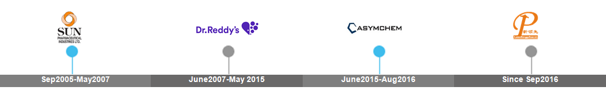

September 2016- till date Chief Scientist
Leadingpharm Medical Technology, Beijing, China

- Product development strategy design and development along with scale up of solid oral formulations.
- Lab scale development and evaluation along with data assessment and interpretation for oral solids, injectable preparations and topical drug products
- Provide a comprehensive risk assessment of drug product, define product complexity in terms of technology, scale up and bio success (BE). Develop scientific and logical ways to support the product`s in-vitro behavior and in-vivo responses through simulation platforms leading to IVIVR for various types of dosage forms. Ideation of structurally design the pilot BE studies to effectively build a relationship between in-vitro/in-vivo and thus utilize the relationship to aid the product development that could lead to 505 b(2) or new patient friendly dosage

- Key technical challenges in developing alternate dosage forms and line extension products across geographies, data review and develop logical and scientific rationale for product development, which can hasten the product development process and draw out meaningful relationships among the experiment and the outcome

- Present scientific evidences for management and leadership committee accounting for decision making during project complexity and evaluation process. Culminate the cross learning knowledge with the CFT (Cross functional Team) members and help in resolve the discrepancies.

- Provide support to ensure compliance to Quality systems, thus minimize the hurdles and gaps during developmental studies, connecting the developmental aspects with the view of scalability and vision of regulatory filing of the drug product.
- Utilized the risk of dosage form changes and patient centric dosage form development approaches using Gastroplus platform and sphere headed the ideation of unmet patient need
June 2015 –August 2016, Senior Research Scientist

Asymchem life sciences, Tianjin, China

- Provide scientific inputs for portfolio leadership and to the key account teams assist decision making during product selection process. Interact with the CFT (Cross functional Meeting) members and resolve the discrepancies and draw out plan and time management.

- Characterization of Innovator product so as to get valuable information which shall help in generic product development and interpretation and compilation of the data

- Ensure compliance to Quality management systems ( QMS ), thus minimize deficiencies related to regulatory authorities, Customer interaction and plan for execution of projects as per the needs of customer

- Help in lay down clear pathway through appropriately planned logistics for kick start of development leading to timely product filing. Support in Review of product development strategy in line with the company interests, non-infringing strategy and check product development completeness and robustness through supervising and guiding the development team

- Monitor product forecasts, working cross-functionally to gather competitive intelligence, for successful development plan, establish Proof of Concept while strategy evolution, hastening development.

- Ensure smooth transition through interface between API, Development team and inputs from cross functional teams to plan from new product to inline and maintain product status.
- Interpersonal relationships with internal development teams, working to ensure effective implementation of project plans to support business objectives.
June 2007 –May 2015, Senior Scientist
Dr. Reddy`s labs, Hyderabad, India
- Building scientific rationale and assess the product development team with regards to the critical biopharmaceutical and pharmacokinetic properties of the drug substance and drug product.

- Strategy planning for product evaluation and selection decision with formulation background and craft Intellectual value creation for the organization leading to Future portfolio /New technologies.

- Systematic and continuous competency building for specific products, methods and processes in the functional area leading to improved metrics

- Development of non-infringing formulations with bioequivalent profiles for the regulated markets (USA) – first to file and complex generics

- Anticipation and understating of reference product before the NDA acceptance and/or availability in the market to achieve first to file

- QbD based development of various dosage forms by applying different concepts like FMEA, DoE, etc.

- Prepare the Scale up and exhibit batch MFR, planning and execution of exhibit batches for the products developed.
- Continuous learning of new development, interaction with external experts, creation of interaction cross functional expertise and formation of scientific forum

September 2005 –May 2007, Research Officer

Sun Pharmaceutical Advanced Research Labs, Mumbai, India

- Key responsibilities included formulation development leading to filing of extended release formulations

- Worked on new Platform Technology for Gastro Retentive and Bilayer Sustained Release formulations.

- Worked on platform technology of controlled drug delivery system through controlled surface exposure.

- Worked on solubility improvement approaches for poorly or conditionally soluble molecules, with a view of improvising their absorption.

- Worked on the projects involving estimation of an absorption window and correlation of the same to their region of absorption and bioavailability.

ACHIEVEMENTS AND AWARDS TARGETED FUNCTIONAL AREA

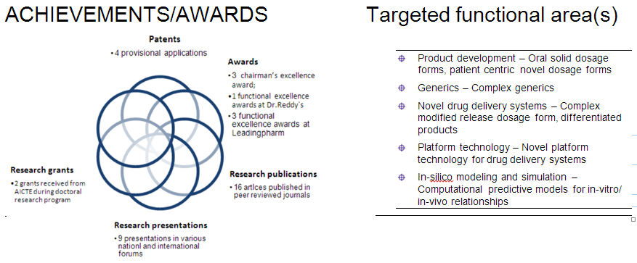

EDUCATIONAL BACKGROUND

