CURRICULUM VITAE

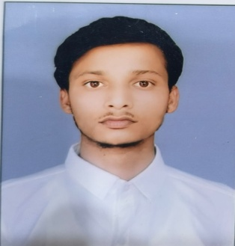
MO ARSHAD
S/O MO SALEEM
Vill-Bhatti Jarauli,
Post Katawan,Distt Sultanpur,Uttar Pradesh.
Mobile No-7239056149
EmailID-arshadansari1639@gmail.com

OBJECTIVE

- Self –motivated and hardworking fresher seeking for an opportunity to work in a challenging environment to prove my skill s and utilize my knowledge &intelligence in the growth of the organization .

EDUCATION/QUALIFICATION

- M.Sc.Passed From Kamla Nehru Institute of Physical and Social Sciences 2024.
- B.Sc.Passed From Ganpat Sahay P.G. college 2022.
- 12thPassed From UP Board 2019.
- 10thPassed From UP Board 2017.

Skills:-

Organic Synthesis

Analytical chemistry

Strength:-
- Positiveattitude
- Honesty
- Hardworking

PersonalDetails:-

- Name | :- | Mo Arshad
- Father Name | :- | Mo Saleem
- Date of Birth | :- | 08/07/2001
- Materials status | :- | Unmarried
- Sex | :- | Male
- Nationality | :- | Indian
- Language | :- | English,Hindi
Declaration:-
- I here declare that Above-Mentioned Information is correct to that best of my knowledge and bear the responsibility for the correctness of the above mentioned particular
Place:- Sultanpur (Mo Arshad )

