RESUME
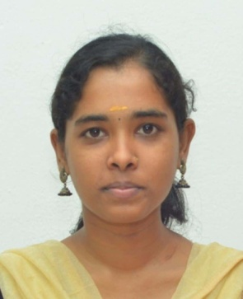
Keerthana Selvadasan
Nationality: Indian
Phone number: 7708676550
Email id: Keerthanathesk@gmail.com
Address: 3/219A, KK Nagar, MLR back side, Perumanallur, Tiruppur-641666.
About me
I’m highly motivated in working with biotechnological techniques and can easily adapt towards the environment. And I’m capable of learning new skills for furnishing my knowledge.
Educational Qualification
Master of Biotechnology
Dr.NGP Arts and Science College, Coimbatore, Tamil Nadu (2023-2025)
Percentage – 72%
PG Diploma in Clinical Laboratory Techniques
Dr.NGP Arts and Science College, Coimbatore, Tamil Nadu (2023-2024)
Percentage – 84%
Bachelor of Biotechnology
Nandha Arts and Science College, Erode, Tamil Nadu (2020-2023)
Percentage – 73%
Higher Secondary School Certificate
Sakthi Vigneshwara Higher Secondary School, Tiruppur, Tamil Nadu (2019-2020)
Percentage – 69%
Secondary School Certificate
Sakthi Vigneshwara Higher Secondary School, Tiruppur, Tamil Nadu (2019-2020)
Percentage – 77%

Project
M.Sc., Project (2024-2025)
In-vitro micro propagation in grape cultivar Vitis vinifera. L Red lobe
ICAR - Indian Institute of Horticultural Research, Hessarghatta, Bangalore, Karnataka.
Internship
• Basic equipments handling and functioning in laboratory.
Government Hospital – Kalasapakkam, Tiruvanamallai, Tamil Nadu
• Isolation, Screening, Antibacterial and Antifouling activity of Actinobacteria.
Bharathidasan University, Triuchirapalli, Tamil Nadu
Workshop
• Zebra Fish Handling and its Hematalogical Analysis (29/12/2023)
Dr.NGP Arts and Science College, Coimbatore, Tamil Nadu
• National workshop on Advanced Characterization techniques (7/3/2024- 8/3/3024)
Amrita Vishwa Vidyapeetham, Coimbatore, Tamil Nadu
• Molecular Mapping for Crop improvement (3/3/2025-5/3/2025)
ICAR - Indian Institute of Horticultural Research, Hessarghatta, Bangalore, Karnataka.
• In silico Prediction of Phytochemical activites: ADMETox and Molecular Docking Studies by IYARVI Research centre for Bioinformatics, Erode (7/10/2023-9/10/2023)
Dr. NGP Arts and Science College, Coimbatore, Tamil Nadu
Technical Skills
• Cell Culture Technique.
• Fermenter handling and moitering.
• Communication skill.
• Instrument Handling.
• Creative Ability
• Adaptability.

Publication
• Published a review article in the journal of “Bhumi Publishing” ISBN NO: 978-93-48620-01-9 in the book entitled “Science and Technology for sustainable Future Volume I” under the book the review article entitled “Review on Isolation of Fluoride from Camellia sinensis leaf for Formulation of Toothpaste”.
Declaration
I hereby declare that the above mentioned information is true to my knowledge and belief.
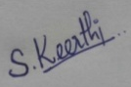
(Keerthana selvadasan)

