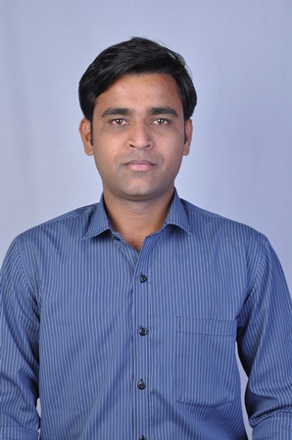
RESUME

Mr. Kishor Magan Baviskar
Address for Correspondence.
Flat No. 12 dhanchaya appt.,
Meri ,dindori road
Nashik-422003.
Maharashtra.
Contact No : 8668246042

Email Id :22kar.kishor@gmail.com

OBJECTIVES :

- To produce sales growth and increase company profits

- To give justice to the job assigned to me.

EDUCATINAL QUALIFICATION :

 | EXAM | SCHOOL/COLLEGE | UNIVERSITY/ BOARD | YEAR OF PASSING | PERCENTAGE
 | Final Year | J.Z.M.D.S College of Pharmacy | North Maharashtra University | 2008-2009 | 57.33%
 | T.Y.B.Pharm | J.Z.M.D.S College of Pharmacy | North Maharashtra University | 2007-2008 | 57.30%
 | S.Y.B.Pharm | J.Z.M.D.S College of Pharmacy | North Maharashtra University | 2006-2007 | 60.41%
 | F.Y.B.Pharm | J.Z.M.D.S College of Pharmacy | North Maharashtra University | 2005-20*06 | 61.16%
 | H.S.C. | Jaihind Jr. College. | Nashik | 2004-2005 | 48.50%
 | S.S.C. | J. R. City high school. | Nashik | 2002-2003 | 69.46%

TECHNICAL EXPOSURE :

- MS-CIT & MS-Office.
EXPERIENCE :
9 years and 3 months of experience as a senior business officer in zydus healthcare(Div-neurosciences).

ACHIEVEMENT:

Achieved annual target of year 2017 by 100.50% and 2019 by 102%.

HOBBIES :

1 Reading,Playing Cricket,Travelling & Interacting with people from different
Backgrounds.

STRENGTHS :

1 Faith in myself, Yet not overconfident.
2 Commitment towards work & new learning.
3 Strong believer in team-work.
PERSONAL DETAILS :

Name : Kishor Magan Baviskar
Date of Birth : 11 Oct. 1986
Sex : Male
Marital Status : Married
Languages : English, Marathi, Hindi.

DECLARATION :

I do hereby declare that the above mention particulars are true the best of my knowledge.

Place : Nashik KISHOR MAGAN BAVISKAR

