Samala Rohith Kumar
H.No: 3-100/B Vill:
Manthani, Mdl: Manthani
Dist: Peddapally, Telangana -505184
9381579014 rohithkumar18286@gmail.com

Objective

To obtain an entry-level position at a respected organization and utilize the educational qualifications I've obtained at University College of science
Education

Course / Degree | School / University | Grade / Score | Year
Msc chemistry(organic chemistry) | Osmania University, Siddipet | Pursuing | 2023-2025
Degree (MCCS) | Roshini degree college, Manthani | 79% | 2020 - 2023
Intermediate (MPC) | Chaitanya junior college, Manthani | 89% | 2018-2020
SSC | ZPHS(boys), Manthani | 82% | 2018

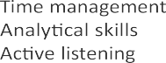


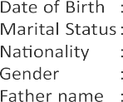
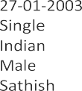

Experience
ICICI Lombard Insurance company (Associate Development Manager) – 3 Months
SAMALA ROHITH KUMAR

