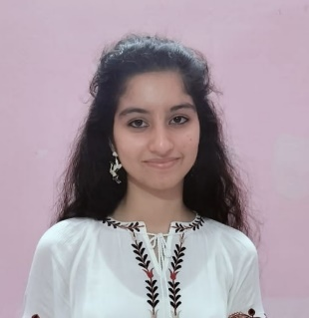 SONAL NARUKA
8955462329 | sonalnaruka007@gmail.com
Plot no. 14, near mehandipur Balaji temple pushkar road
Kotra, Ajmer Rajasthan.

OBJECTIVE
- Opportunity to connect to the position of Quality control.
EDUCATION
Sophia Girls’ College (Autonomous), Ajmer
Masters of Science, Chemistry, 2024
Specialization in organic chemistry
Relevant certificate coursework:
- HR Recruiter Training
- HR Generalist & Payroll Training
- HR Analytics Training
- Talent Acquistion Training
- MS Excel Training
Sophia Girls’ College (Autonomous), Ajmer
Bachler’s of Science, Biology, 2022
Queen Mary’s Girl’s School, Ajmer, 2019
SKILLS
- MS Word
- MS Excel
- Power Point
- Presentation capability
- English fluency
- Teaching skills
- Constant learning
HONORS &REWARDS
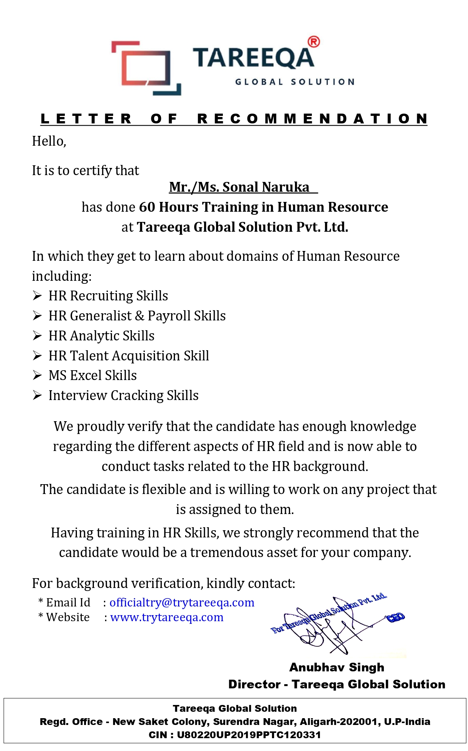

DECLARATION
SONAL NARUKA, 19-12-2023, 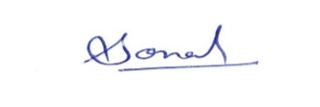
- Accept that all information is verified and right.

