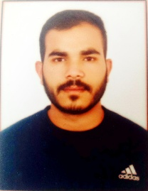
Ritik Lilhare
Balaghat, Madhya Pradesh- 481222. 7470327705 ritiklilhare2002@gmail.com
https://www.linkedin.com/in/ritik-lilhare-71b132284

Objective

To grow with a leading organisation that utilizes my ability to the fullest extent possible, helping me realise and develop my potential.

Education

Course/ Degree | School/College | Grade/CGPA | Year
10th | Govt. Higher Secondary School, Bahela, Balaghat. | 80% | 2018
12th | Govt. Higher Secondary School, Bahela, Balaghat. | 75% | 2020
B. Pharmacy | Bansal College Of Pharmacy, Bhopal | 8.19 CGPA | 2020-2024

Academic Project

Project Title: A Comprehensive Study on Antidiabetic Agents and Their Molecular Targets.
Project Guide: Prof. Mrs. Renuka Namdeo, Dept. Of Ph. Medical Chemistry, Bansal College Of Pharmacy, Bhopal, M.P.
Duration: JAN 2024 to JUNE 2024

Technical skills

- Basic knowledge of computer
- MS Office

Skills

- Leadership
- Flexible and Adaptable
- Teamwork and Collaboration
- Multitasking Abilities
- Planning and Coordinating

Area of interest

- Production
- Quality control
- Quality assurance

Hobbies

- Playing Cricket
- Travelling
- Watching Webseries and Movies

Languages

- Hindi
- English

Personal details

  - Father’s name- Mr. Parshuram Lilhare
  - Date of Birth: 01/03/2002
  - Gender: Male
  - Nationality: Indian
  - Marital Status: Unmarried
  - Address: At.Gorre, Post. Maneri, Block. Lanji Balaghat, Madhya Pradesh
Pin code-481222
Signature
Ritik Lilhare

