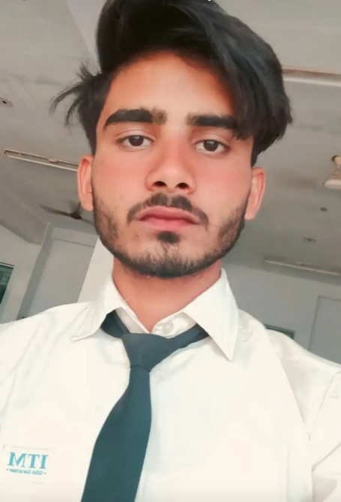
Md. Saqib

📍 Khalilabad, District Sant Kabir Nagar, Uttar Pradesh
📞 8400742337 ✉️ saqibkhalilabad@gmail.com
Date of Birth: 05/02/2005
---
Career Objective

To start my career in a reputed pharmaceutical company where I can learn and grow while contributing to production and quality standards. I aim to gain hands-on experience in pharmaceutical manufacturing and packaging operations.
---
Educational Qualification

• Diploma in Pharmacy – ITM College of Pharmacy and Research, 2024
• Intermediate (12th) – HRIC Inter College, 2022
• High School (10th) – Navals National Academy, 2020
---
Internship

Completed 3-month internship at Community Health Centre (CHC), where I gained experience in handling prescriptions, dispensing medicines, and understanding pharmacy operations.
---
Skills
• Knowledge of pharmaceutical production and packaging process
• Basic understanding of GMP and safety protocols
• Good communication and teamwork abilities
• Quick learner and disciplined worker
---
Personal Details

Father’s Name: Abdul Aziz
Date of Birth: 05 February 2005
Gender: Male
Marital Status: Single
Languages Known: Hindi, English
Nationality: Indian
---
Declaration

I hereby declare that the above information is true to the best of my knowledge and belief.

Place: Khalilabad
Date: 31/10/2025
Signature: Md. Saqib

